Alerton CVE Scripts How-To

# Topology of Lab

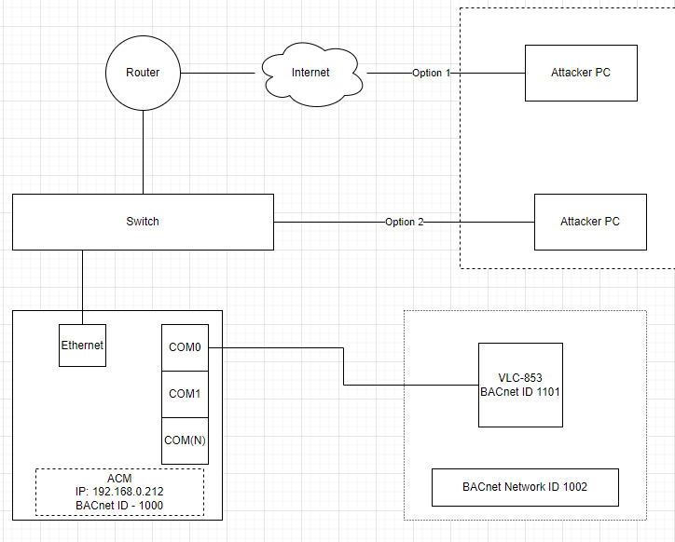

# Configuration Change Script

1. Verify that Configuration is set so that COM 0 is enabled.
   1. Open Compass software
   2. Click Compass in top left corner → Device Manager
   3. Click on the ACM record and then on “configure…” on the right side of the window
   4. Click BACnet Configuration → MS/TP Configuration → COM0 MS/TP Configuration → check the Enable MS/TP on COM0 checkbox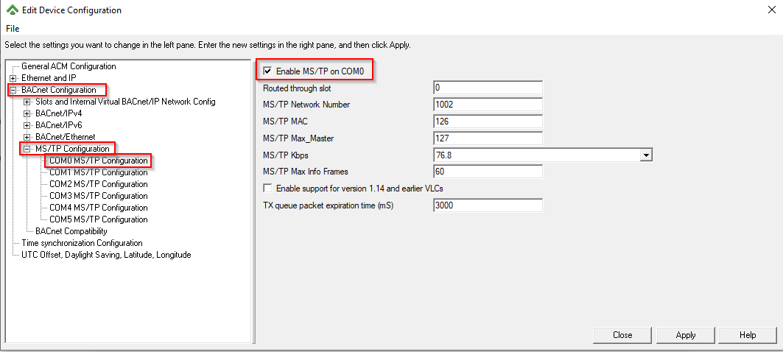
   5. Click apply → Close
   6. Click Yes on the pop up asking to save changes (if it doesn’t pop up, click on the checkbox twice - once to disable and then enable and the pop up will appear after repeating step e)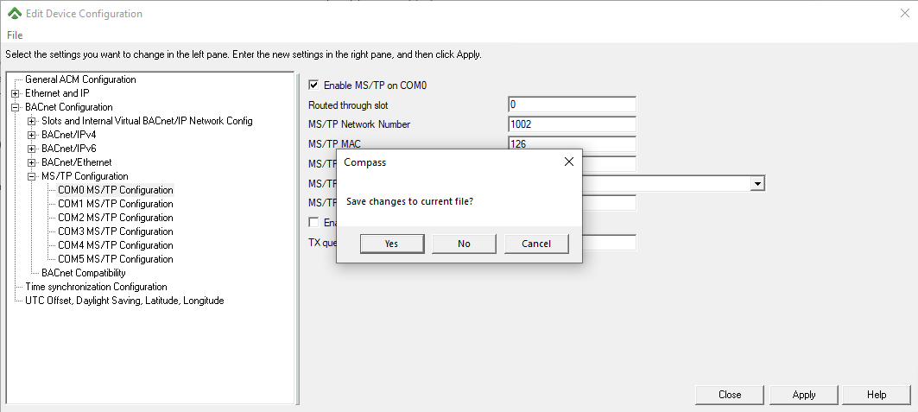
2. Run the script that changes the configuration of COM0 to be disabled ()
3. After the script finishes with a success message
   1. verify that the Top Display indicates a connection failure
      1. From the main display in the Compass software, click view → Top Display
      2. In the browser window that pops up, notice that VLC-853 has <NR> (Not Responsive) for all values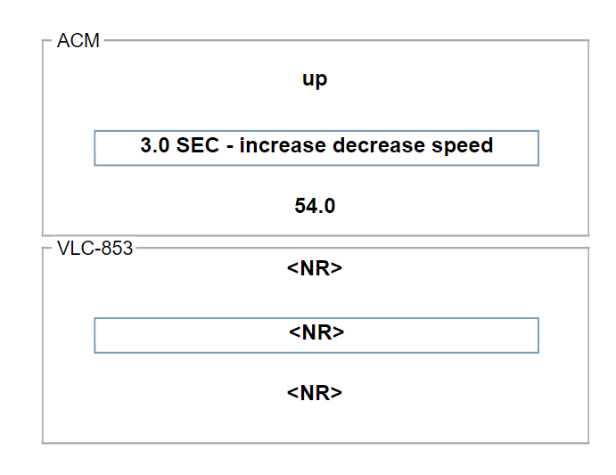
   2. Verify that the configuration in the Compass software still indicates that COM0 is enabled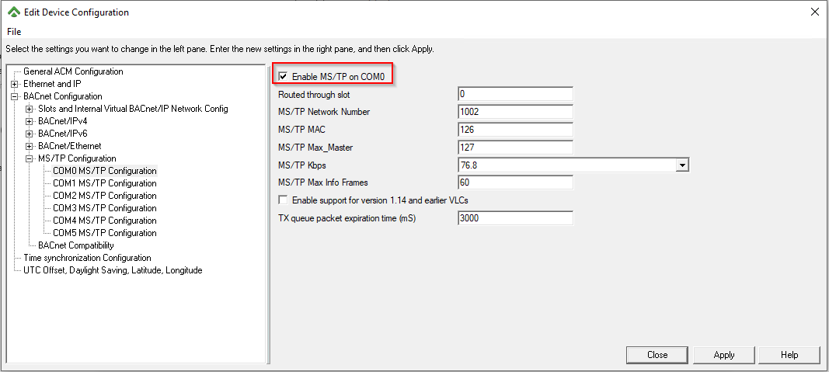

# Programming Change Script

1. Verify that program is running on the controller matches the program open in the programming software
   1. Open Visio with Visual Logic add on installed
   2. Open a DDC project file
   3. In Visual Logic tab, click “Send to Device” → On the next pop up click send (where the parameters match those seen in the image)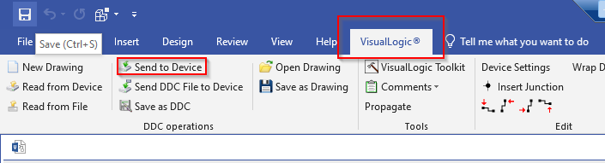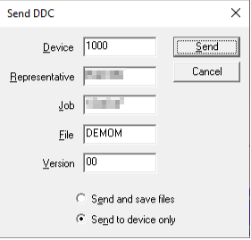
2. Run the script that overwrites the program
3. Verify that the program running on the control
   1. Has changed
      1. Click “Read from Device” and see in the window that opened that an additional code block was added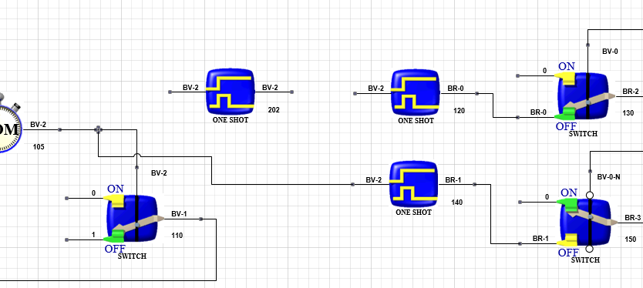
   2. Is different than the program displayed in the programming software
      1. Click “Read from File” and see that the program stored in the file doesn’t match the program that was downloaded